Introduction: At the dawn of the nineteenth century, Canada was not the developed, prosperous country it would eventually become. Its vast spaces, often rocky and forbidding to farmers, and its cold winters made northern and western Canada far less attractive to settlers than the United States. For many years, these regions, including B.C., were inhabited by the Native peoples and a small group of daring fur traders, and no one else.
In the east, Canada was certainly growing. The population of Upper Canada (now southern and eastern Ontario) had risen rapidly after the end of the War of 1812, as immigrants from Europe and the U.S. arrive to take advantage of cheap land.

The Immigrant Experience

1. Nobody who lived in British North America could have been prepared for the waves of immigrants who arrived at the close of the War of 1812. Most of these immigrants settled in Upper Canada. The map on page 23 shows the number of immigrants who came to Upper Canada between 1831 and 1836. Look at the numbers of people who settled in Upper Canada and add them all up. How many immigrants arrived in Upper Canada in this 5 year period? __123,000___ (p23)

2. a) What parts of the world did most of the new immigrants arriving in Upper Canada come from? (p23)

___Great Britain___ ___America___ ___Europe____

b) All of these immigrants arriving in Upper Canada were attracted by the widespread advertising campaigns that the Canada Company posted all over the U.S., Britain and parts of Europe. What did these posters promise the immigrants would find when they arrived in Upper Canada? (p23)

They were wooed with promises of cheap, fertile land close to towns and markets---the poster painted a very optimistic picture of life in Canada.

3. The overpopulated cities and countryside of Britain supplied Canada with many new immigrants. List two different reasons people from these places would leave their homeland for a new life in Upper Canada.

- Poor and displaced tenant farmers from Ireland and Scotland came to Canada for a chance to own their own land.

- Canada also gave lower class immigrants a chance to escape the stifling class system of the old country

Upper Canada

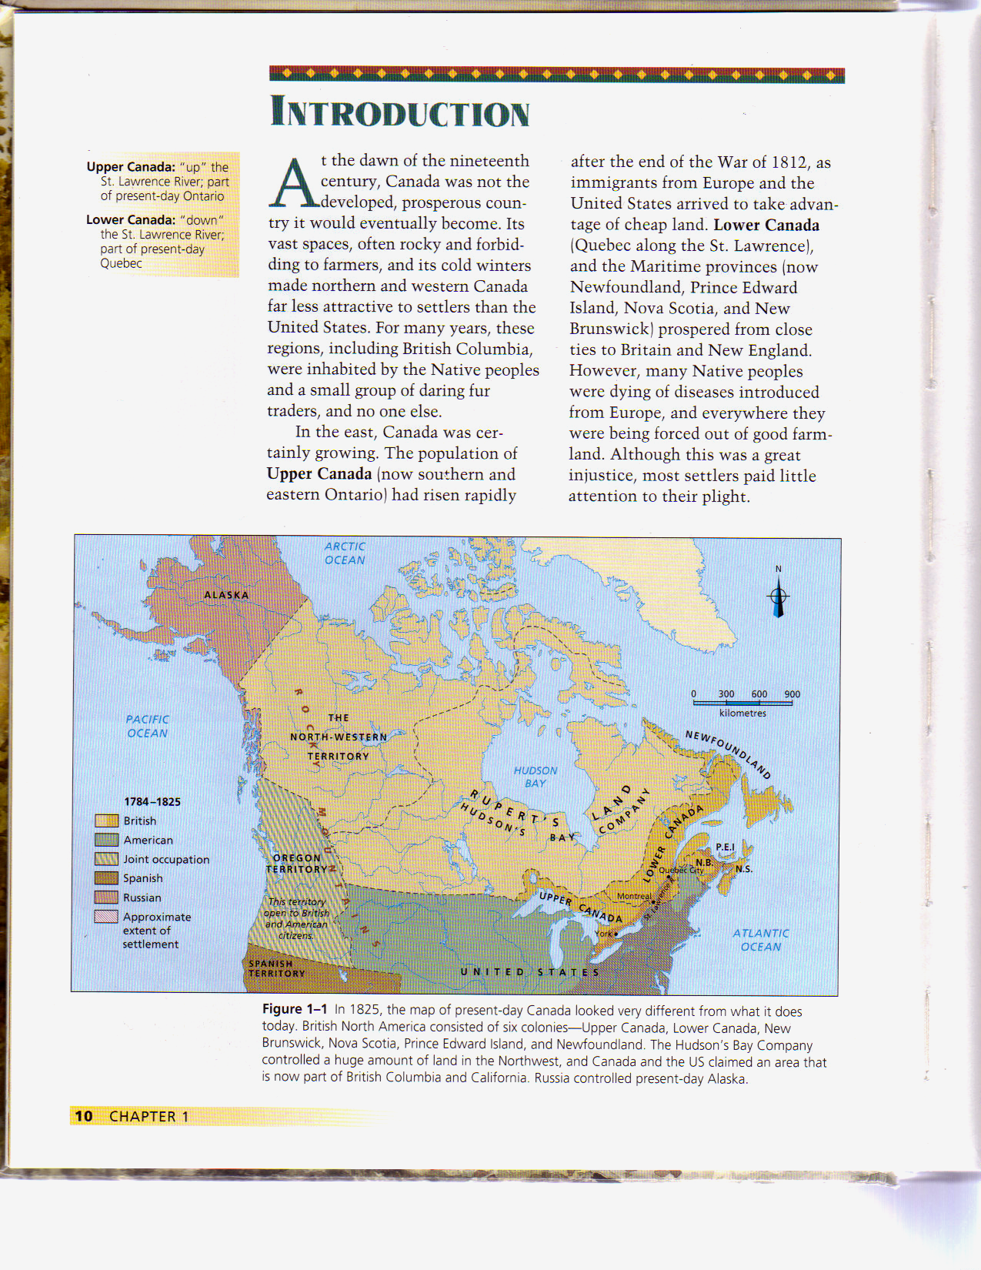

4. a) Following the war of 1812, settlers poured into Upper Canada. What attracted these settlers to Upper Canada? (p14)

The rich and relatively inexpensive farmland.

- Most immigrants to British North America (BNA) wanted to farm. Why was Upper Canada a good place for farmers to settle? (p14)

Fertile soils of Upper Canada and the groves of timber-producing hardwoods.

- What land in Upper Canada was most desirable for new immigrants? Where in Upper Canada was this most desirable land? (p14)

Most desirable was the land closest to the U.S. and to the waterways. This land was in the south—by the U.S. border. (see map on page 16)

- There was land not suitable for farming in Upper Canada as well. Where was this land and why was it not suitable for farming? (p14)

In the northern regions…not suitable for agriculture because it was on the Canadian Shield—rock and the climate was not suitable—to short of a growing season.

- The early 1800s was an era of few roads. What difficulty did this pose for new immigrants? (p14)

Few roads meant it would take several days to travel 100 kilometres. Land 50km away from the main towns—York, Cornwall, Niagra was considered to be remote because of the traveling time.

5. a) How did Upper Canada compare with other BNA colonies in the early 1800s? (in terms of development) (p16) In the early 19th century, Upper Canada was the newest and most underdeveloped of all the colonies in BNA.

- What almost happened to Upper Canada during the War of 1812? (p16)

The Americans invaded Upper Canada during the war, and their takeover was almost successful—the Americans were the largest group of immigrants in BNA at the time.

- What were the roads like in Upper Canada during these early years? What did mean for any land further than 30km from any village? (p16)

There were few roads—even the military routes were just tracks through the bush. Places at a distance of 30-40 km were considered to be remote because they were in the middle of a forest with no roads.

- New immigrants who came to farm Upper Canada had to first clear the land. Was this an easy task? Explain. (p16-17)

The forest cover was heavy, with great giant oak, walnut, ash, hickory, and maple trees. Clearing these trees was no easy task—it took a lot of time. No more than 1 hectare could be cleared in a year. Normally it would take a family 20 or more years to clear a 25-hectare farm---a little larger than a city block.

6. In point form, describe what life was like for immigrants who came to farm Upper Canada in the early 1800s. The information for this answer starts at the paragraph on page 17 that begins with “It was much more common to….” and ends with “…and mortgaged their next crop to obtain supplies.”)

- Neighbours depended on each other for companionship and for help when a job required more than one man—pioneer life was a lonely existence.
- People looked forward to going to church and to have a visit from a traveling member of the clergy.
- Communities had to pool their resources to set up a school and to hire a teacher—who was often paid with produce, lodging and meals rather than cash.
- Almost everyone went into debt because it took years to raise a crop big enough to have some left over after the family took what it needed. Many had to mortgage the next years crop to buy this years supplies.

The Importance of Social Class in Upper Canada

In Europe, society was divided into three social groups: Upper class (rich aristocrats who owned large pieces of land and did not have to work for a living), middle class (professionals and businessmen) and lower class (poor people who might have been labourers in the factories or tenant farmers). In Europe, the people from different social classes did not mix together except in a business or working relationship. People of different social classes did not attend the same social functions. And, generally speaking, you lived your whole life in the class you were born into. For instance, if your parents were members of the lower class, then so were you. If you were not born to Upper Class parents, then you had no hope of ever becoming a member of the Upper Classes. The only way you could improve your situation was to leave home and move to a country that did not have social class divisions.

7. a) Upper Canada had a way of leveling people (leveling out means the disappearance of social class divisions—making a society where everybody is equal and has equal opportunity.) Explain why social class divisions were not important to immigrants who came to farm in Upper Canada. (p19 & 20)

Social classes in the old country never mixed on a social level—the lower classes served the upper classes. It was different in pioneer life. Immigrants from the upper classes had to do their own manual labour as there were few servants in BNA---everyone came to farm their own land
- What conditions in Britain and Europe made it easy for social class divisions to exist? (p19-20)

Overpopulation and a lack of labour laws made poorer people desperate for employment, so upper class people could live apart from the so-called lower classes.

- What was it about some of the educated British immigrants that would suggest some of them might want to recreate the same type of social class divisions in Upper Canada that existed in their homeland? (p20)

Educated people were very interested in English culture. They did not see themselves as Canadians, but rather as English people settling in a new land.

The Family Compact

Members of the PRIVILEGED UPPER CLASS IN UPPER CANADA were known as the “FAMILY COMPACT.” They were a small group of men WHO CONTROLLED THE GOVERNMENT of Upper Canada and thus controlled what did, or did not, happen in Upper Canada.

8. a) Members of the Family Compact moved to Canada following the American War of Independence in 1776. Where did they come from and why did they move to Upper Canada? (p19)

They were the loyalists that left the U.S. when the U.S. successfully separated from Britain—thereby being an independent country rather than one of the British colonies. Leaving the U.S. and moving to BNA meant they could remain connected to Britain.

- How did members of the Family Compact see themselves in relation to other immigrants settling in Upper Canada?

Members of the Family Compact saw themselves as superior to others.

- What part of Upper Canada’s gov’t did the Family Compact control? What important function(s) of the government did they control? (p19)

They made up most of the executive council, and had control over government budgets and appointments.

d) The Family Compact used the power they held in Upper Canada’s gov’t to get the gov’t to pay for projects that would make themselves and their families very rich. What kind of projects would this be? (see the caption for Figure 1-11 on page 19 for this answer)

Family Compact members invested money into ships and canals. They used their influence to get gov’t backing of these projects, and benefited financially from their success.

e) What were members of the Family Compact like on a social level? (social refers to the people they hang out with when they are not working, what they like to do, what they like to wear etc.) (p19)

On a social level, they were snobbish to the extreme. Even aristocratic visitors from Britain had a hard time breaking into this group, which operated like a private club. All members knew each other and were often related. They even dressed alike.

The Problem of Land in Upper Canada

9. Almost everyone who came to Upper Canada in the early 1800s had some interest in farming. Explain. (p20)

They came to farm so most people needed land, and they wanted to be farmer on their own land—not to tenant farm. If they didn’t farm, they were engaged in farm-support businesses/industries (blacksmithing and wagon making).

10. a) What did advertising campaigns in England—and later in Europe—lead people to believe they’d find when they arrived in Upper Canada? (p20)

They led people to believe that they could get good, cheap, farmland with easy access to towns and markets.

- What the immigrants found when they arrived to Upper Canada was not what was promised in the advertisements. Explain. (p20)

The cheap, fertile land close to towns and markets were already taken up. The only land available was far from any towns/markets and there were no roads and no established communities.

- What effect did the problems with the land have on the lives of the new immigrants? How did they feel? Who did they blame? (p20)

Problems associated with restrictions on land and poor roads caused great hardship for many, and much discontent. Everyone felt like they had been cheated. They blamed the Family Compact because they much of the land belonged to them, but they weren’t using it and, their position of influence in the gov’t gave them the power to fix the problems but they refused.

11. a) Many members of the Family Compact were land speculators. What is a land speculator? Why did they do this? (p20)

Land speculators are those buy property at a low price and sell it at a higher price without spending much of their own money.

b) Explain what the land speculators did in order to make sure their land brought in the highest profits possible? (p20)

Supply and demand---the speculators bought up the cheap, fertile land close to towns and markets while the prices were low. They held onto the land until all the surrounding land was sold. Once there was no more available land, they would put their land up for sale at a much higher price---the less land available, the higher the price.

c) What effect would their decision not to sell any land, at least until the price was high enough, have on the new immigrants arriving in Upper Canada? (p20)

The new immigrants were forced to buy land 50 to 100 km away from the towns and markets. Even after the Family Compact put their land up for sale, the price would be too high for many of new immigrants to pay.

Crown and Clergy Reserves (p21)
12. a) What are crown and clergy reserves?

Blocks of land set aside to provide income (through sale or rent) for the gov’t and for the Anglican Church.

- How much of the land in Upper Canada was set aside in these reserves?

In total, two-sevenths of all the land in Upper Canada.

- How did these land reserves affect the farmers in Upper Canada?

For the most part, these lands lay idle. And because they were scattered through the townships and were not cleared, the reserves blocked road development, causing much grief to settlers. Farmers had to wind their way around reserves if they wanted to travel anywhere—a waste of time and a source of irritations. Moreover, the reserves often tied up prime, arable land.

- How did the existence of the land reserves affect the price of farmland?

Because of the economics of supply and demand, this caused the value of land to rise even higher.

The Role of the British Government
13. Upper Canada’s land problem was partly created by the attitudes of the British government. Explain. (p21)

The British gov’t wanted to duplicate the English model of landowning. England was a land of large estates controlled by the aristocrats.

14. a) Which group of people in Britain and in Upper Canada did the British gov’t think were the best people to rule a country, or in Upper Canada’s case, to rule the colony? (p21)

The gov’t believed the aristocrats could best rule Upper Canada.

- What other reason did the British government think the aristocrats were best suited to run Upper Canada? (p21)

Privileged owners of large blocks of land were also more likely, in the British government’s view, to maintain strong ties with Britain and British institutions.

- Most of the immigrants that came to farm Upper Canada had republican views and these republican views were different from the views held by the British government discussed in questions 14(a) & 14(b) above. What does the term republican mean? Explain these republican views the immigrant farmers held. (p21)

Democratic governments without a monarch as the Head of State.
15. a) It was very true that Canada’s government, which was controlled by the members of the Family Compact, was discriminatory and anti-democratic in the early 1800s. Explain what discriminatory and anti-democratic means. (I’ll help you with this question in class)

Discriminatory means not all people were treated the same. Some groups were given rights and privileges that other groups were not given. Anti-democratic means that not all people who serve in the government are elected by the people, some were appointed by the powers that be—like the governor of the colony.

- Britain knew the gov’t of Upper Canada was discriminatory and anti-democratic.—they actually preferred it like that because they did not want a repeat of what happened in the United States. Explain. (p21)

If Britain allowed BNA to adopt American attitudes and values (republican), then BNA may start a revolution to cut all ties with Britain the same way the U.S. did in 1776)

At the beginning of the 19th century (1800s), there were thousands of hectares of land in Upper Canada that were available to “take up” and develop. The gov’t allowed land companies, such as the Canada Company, to acquire vast tracts of prime land at a very low price. The Canada Company, with Family Compact connections, purchased lands that stretched from Lake Ontario to Lake Huron.

16. a) The Canada Company bought up most of the prime farm land at low prices. What did the gov’t make the Canada Company responsible for? (p22)

Attracting settlers the Upper Canada. These were the people that ran the massive advertising campaign that promised immigrants the cheap, fertile land close to towns and markets—promises that turned out to be lies.

- Approximately, how much money could the land speculators who bought up the land at low prices make within ten years? (p22)

Many could double their money within 10 years.

- What is a land speculator? (p20) How much of the land in Upper Canada was owned by land speculators? (p22) Land speculators buy land at a low price and sell it at a higher price without spending any/or much money on making improvements. In 1815, almost 50% of all farmland in western Upper Canada

- The land speculators bought up the best available farm land and would not sell it until the surrounding land was sold off—this would drive up the value of the land they owned. Describe the land that land speculators bought up. (p22)

—the best available land because it was level, with deep soil and few rocks—was owned by speculators.

Colonial Government and the Need for Reform

17. a) Democratic governments today are usually both representative and responsible. Unfortunately, In the early 1880s, governments in the colonies of British North America were neither representative nor responsible. What is a representative government? What is a responsible government? (p33)

Representative—a gov’t in which representatives are elected by people to make laws on their behalf—because it is not possible for the people to make laws themselves. Responsible—a gov’t which can be voted out by the people if the people are not pleased with how they do their job—you can only be voted out if you were elected, you cannot vote out a gov’t member that was appointed to their job by the governor.

- Whose hands was the power of colonial governments placed in? What do we call this type of gov’t? (p33)

Colonial governments were placed in the hand of a small group of rich and influential men—The name for the type of gov’t that is controlled by a small group of rich and influential men is called an OLIGARCHY.

- Britain appointed a Governor who was supposed to control the oligarchy in the colony, however the Governor did not control it. Explain. (p33)

In reality, the Oligarchy controlled the Governor---the Governor ruled according to the wishes of the Oligarchy. In other words, the Oligarchy told the Governor what they wanted, and the Governor ruled accordingly.
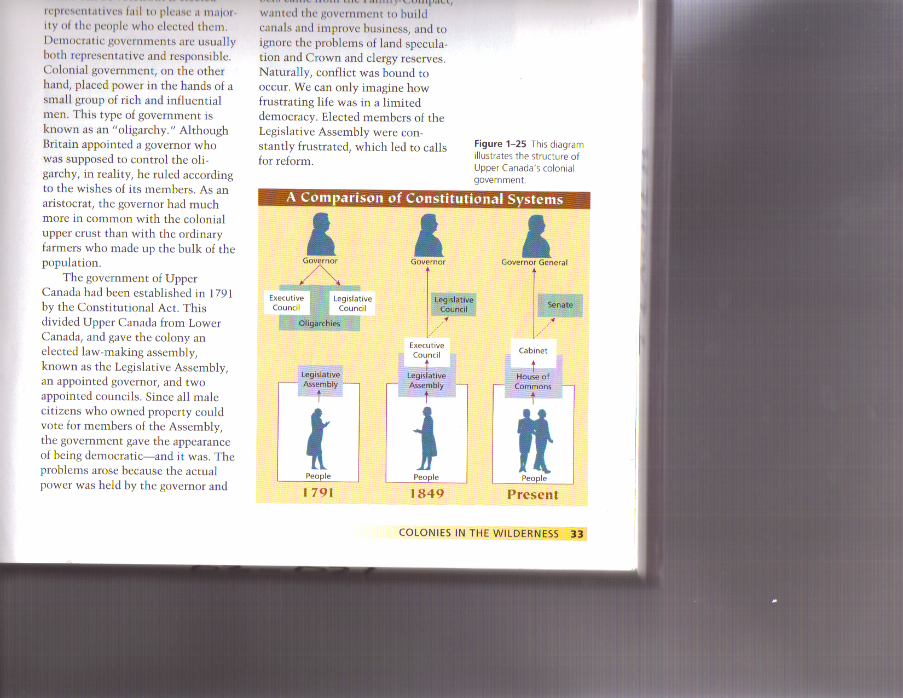
In 1791, the structure of Upper Canada’s gov’t included 1) an elected law making assembly, known as the Legislative Assembly and 2) an governor appointed by Britain and two councils appointed by the governor. During this era, the only people who could vote in elections were men who owned property.

The definition of a democratic gov’t is a gov’t where the voting citizens get to choose/elect who governs them—and these people who are elected have the power to make laws. When gov’t members are elected by the people, then they are responsible to the people—when a gov’t is responsible to the people, it is called a responsible gov’t—to be responsible, a gov’t can only be responsible to the people.

18(a) Look at the diagram above and comment on why this gov’t structure appears to be democratic and responsible. (p33)

It appears democratic because the Legislative Assembly is elected by the people. It appears to be responsible because the Legislative Assembly is elected by the people and therefore responsible to the people.

b) In reality, the gov’t of Upper Canada was not democratic. Why? (p33)
Because not every member of the gov’t is elected by the people, or if appointed, they are not appointed by an elected member—the OLIGARCHY in BNA’s colonial gov’t is appointed by the governor, and the governor is not elected by the people.

The government of Canada was not responsible either. By definition, responsible governments can be voted out if the people are not pleased with their decisions. This ensures that a gov’t listens to and responds to the wishes of the people—that is, if they want to keep their jobs. The problem with the colonial gov’t is that it did not listen to the people, nor did it respond to their wishes. The bigger problem however was the fact that the people could not vote out the gov’t that was ignoring them. So, if the people were not happy with the decisions of its gov’t, and the people were powerless to vote them out, the gov’t then, by definition, cannot be responsible.

So, if they were not responding to the wishes of the people, whose wishes were the government members responding to? The answer to this question…they were pleasing their employer—the one who gave them their job and the one who could take it away. An employee is always responsible to their employer—the one who they listen to and the one whose wishes they will respond to.

c) Which part(s) of the colonial gov’t was responsible to the people, which part(s) was responsible to someone else. Remember, they will be trying to please the one they’re responsible to. (p33)

i) Who gives the members of the Legislative Assembly their gov’t job? The people Who is the Legislative Assembly responsible to? The people .

ii) Who gives members of the Executive and Legislative Councils their gov’t jobs? The Governor . Who are these councils responsible to? The Governor .

iii) Who gives the Governor his job? The British Monarch Who is the governor responsible to? The British Monarch .

The Veto Power…
Another aspect of the colonial government that prevented the people’s representatives in the Legislative Assembly (and thus the people themselves) from having any kind of power in the government decision making process was the veto power the British government gave to the colony’s oligarchy. In fact, it was this veto power that drove the people’s frustration with their gov’t to an unprecedented height.

19. What power did the “veto power” give the Oligarchy over the elected Legislative Assembly? (p33)
Any gov’t decision/law made or passed by the elected members could be vetoed (stopped) by the Oligarchy. If a law passed by the elected representatives was vetoed, that was the end of it.

20. a) What did the elected members of the Legislative Assembly in Upper Canada want the gov’t to spend money on? (p33) Projects that would benefit ordinary people, such as schools and roads.

b) The elected members of the Legislative Assembly also wanted land reform. What was the problem with the land that they wanted reformed or changed? (hint: the Family Compact ignored these problems) (p33)
land speculators and Crown and clergy reserves.

21. a) What did the appointed Executive and Legislative Councils want the gov’t to spend money on? (p33)
To build canals and to improve business.

- What did they think about the elected Legislative Assembly’s call for land reform? (p33)
Not much—they just continually ignored them.

22. When the appointed Executive and Legislative Councils ignored the calls for land reform, the calls changed from land reform to government reform. What does this mean? (p33)
If the oligarchy had the power to ignore the people’s wishes around land reform—to make some rules to protect the people from the land speculators and to address the problems associated with Crown and clergy reserves, then the problem was with this veto power. To get rid of the Oligarchy’s veto power would mean they’d have to change to the way the gov’t was structured and/or the powers given to each part in the structure. If they could reform the gov’t, then they work on land reforms.

A List of Grievances (grievances means complaints)

23. a) What grievance did the settlers in Upper Canada complain the loudest about? (p34) ___land .

b) What person or people did many of the settlers in Upper Canada blame for the land problems? (p34)
The Family Compact.

24. a) Robert Gourlay was the first person to take a leadership role among the settlers calling for reform. These people came to be called the “Reformers.” What action did Robert Gourlay take to get the gov’t to listen to their complaints? Was he successful in getting the gov’t to listen to their grievances? Explain. (p34)
Action—he surveyed the settlers to see what their grievances were, and then he listed them on a petition.
Successful---no. The gov’t was in no mood to listen to their complaints, and it was not about to change its policies no matter what the average farmer thought.

b) Why did the gov’t handle Robert Gourlay the way they did? What effect did the government’s action have on the settlers of Upper Canada? (p34) They arrested Gourlay and sent him out of the country. Instead of deterring them from repeating Gourlay’s actions, it actually hardened their opposition to the Family Compact, and another person—William Lyon Mackenzie—took his place.

22. Who is the man in this picture? What did he do to help the settlers settle their grievances with the gov’t/Family Compact? (p34)

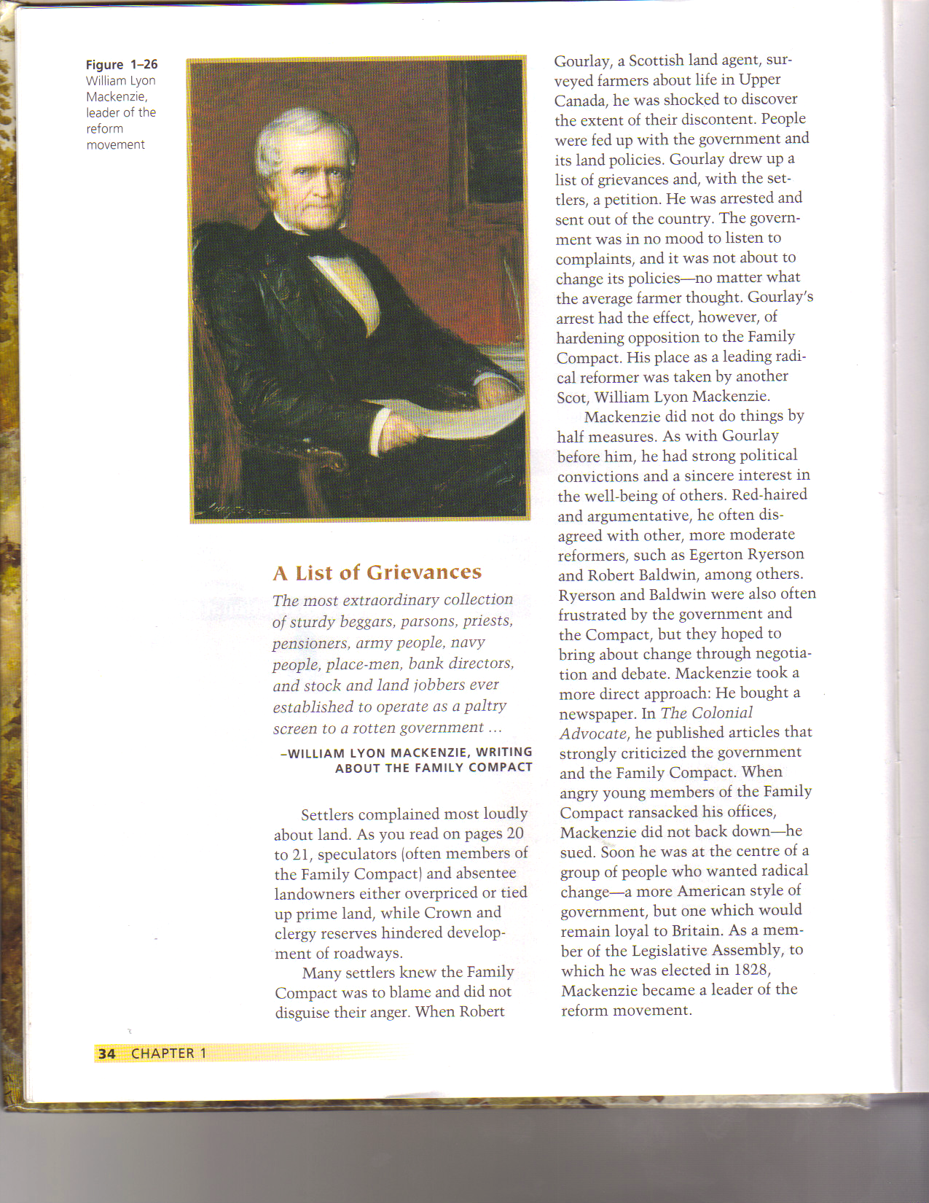

The man is William Lyon Mackenzie. Like Gourlay, he had strong political convictions and he was very argumentative. He often disagreed with the more moderate reformers who want reform also, but they were more willing to bring change about through negotiation and debate. Mackenzie new this would not work so he took a more direct approach. He bought a newspaper—the Colonial Advocate—where he published articles that strongly criticized the gov’t and the Family Compact.

23. What kind of a government did William Lyon Mackenzie and the reformers want for Upper Canada? What kind of connection with Britain did these reformers want? (p34)
They wanted a more American style government, but one that remained loyal to Britain.

24. What was the difference between the moderate and radical reformers? (p34)
The more moderate reformers were just as frustrated as the radical reformers but they hoped to bring about change through negotiation and debate. The radical reformers like Gourlay and Mackenzie were willing to take more drastic action and will go so far as to force change.

25. What happened to William Lyon Mackenzie in 1828? (p34)
He was elected to the Legislative Assembly and became the leader of the reform movement.

Stirrings in Lower Canada (now Quebec)

26. As with Upper Canada, Lower Canada had serious political problems. In some respects, these problems were more serious than those of Upper Canada. Explain. (p37) They had a different culture and language and the French Canadians had never completely adjusted to the British conquest. Exposed to the ideas of the French and American Revolutions, and to the democracy of the U.S., educated French Canadians found British rule without democracy difficult to except.

27. Who controlled the government in Lower Canada? (p37)
Like Upper Canada, control of Lower Canada was in the hands of an oligarchy of merchants and ex-army officers—all English speaking. Profit was the only reason they maintained ties with the Church and with some wealthy French- Canadian landowners.

28. Lower Canada did not experience the same kind of problems with the land as Upper Canada did. Why? (p37)
Because the land had been settled for centuries—most of which was controlled by French-Canadian seigneurial families. So the French farmed and the English settled in the cities where they ran the businesses and controlled the financial industries.

29. If the grievances in Lower Canada were not about land problems, what were their grievances about? (p37)
They were about the English in Lower Canada. The English seemed to have most of the advantages, even though there were only 80,000 in a population of 420,000. Many French people believed that the seigneurs and the Church had “sold out” to English interests.

30. What event occurred in 1822 that the French speaking people in Lower Canada interpreted as an attack on their French culture? (p37) An attempt to join the two colonies in 1822, and to make English the official language of the union, seemed like an attack on French society. Most certainly, it seemed to make the French a minority in a larger English colony.

Feelings of Nationalism in Lower Canada

31. What did French-Canadians in Lower Canada believe the British government was doing to solve the “French problem” in Lower Canada? (Look for two things: one to do with immigrants, the other to do with disease) (p38)
By bringing more English immigrants into the colony so they could change the old seigneurial system into a British freehold land system. Some time later, when ships loaded with cholera-stricken Irish immigrants began landing in Quebec, many thought that Britain had plans to kill of the French-Canadian population with disease.

32. Reformers in Lower Canada were frustrated in their attempts to being about change in the government. They had a small group of men who controlled the gov’t in the same way that the Family Compact controlled the gov’t in Upper Canada. What was the name of this group in Lower Canada? Chateau Clique .

33. What were the three issues in Lower Canada that became the focus of reform there? (p38)
1) Discrimination against the French
2) Unequal taxation
3) Lack of power within the government

34. a) William Lyon Mackenzie led the reformers in Upper Canada. Who led the reformers in Lower Canada? Louis-Joseph Papineau (p38)

b) What did they all believe should change about the government in Lower Canada? (p38)
The French believed that the Assembly should have complete control of the gov’t budget, and they want a more American style republic.

35. In rival newspapers, and in government, the Chateau Clique and reformers squared off against each other. Britain did little to ease tensions. Explain. (p38-39) In 1810, the colonial office appointed the anti-French James Craig as governor. Craig arrested those who criticized the gov’t and brought in soldiers to intimidate the French population. He also closed the Canadien, a reformist newspaper and proposed to unite Upper and Lower Canada in 1822 to make the French a minority in a huge English colony added to the tensions instead of easing them.

36. a) In 1832 in Montreal, some British soldiers shot some French protestors. What did Papineau and other reformers in Lower Canada do as a result of these shootings? (p39) They submitted their “Ninety-two Resolutions” to the governor. It demanded a complete change in the way the colony was governed.

- When and why did the reformers in Lower Canada openly rebel against the government? (p39)
When the Colonial Office in Britain responds to their “Ninety-two Resolutions” with their “Ten Resolutions” that denied the rights of the Assembly the reformers demanded.

The Rebellions of 1837 (Upper & Lower Canada)

37. Did William Lyon Mackenzie of Upper Canada and Louis-Joseph Papineau of Lower Canada know each other? Explain. (p39)
The reformers from both colonies stayed in touch with each other. They shared their views on government and the economy, and exchanged possible solutions to problems. The leaders of the reform movements were particularly close, although their goals were not always in harmony.

38. When did it become clear to Mackenzie and Papineau that it was time to prepare for an armed attack on their governments? (p40)
When it became clear that their governments could not be reformed from within—and that it was nearly impossible to weaken the powers of the Chateau Clique and of the Family Compact—Mackenzie and Papineau prepared for armed attacks on their government.

39. a) In spite of the best-laid plans, the revolts in Upper and Lower Canada were not well-coordinated—meaning they did happen at the same time as planned. Rebellion actually broke out in Lower Canada first, ahead of schedule. What caused this to happen? (p41)
They were planned at the same time because Britain did not have enough troops to fight back everywhere at the same time. But when the authorities in Lower Canada got wind of the rebellion, they attempted to arrest Papineau and this started rebellion earlier than scheduled.

- Who won the rebellion, the government or the reformers? The government (p41)

Rebellion in Upper Canada

40. In 1836, Lord John Russell, the man in charge of the colonial office in Britain, denied the demands of Upper and Lower Canada for a complete change in the way the colonies were governed. His decision was written in a report called the Ten Resolutions. This report, along with the appointment of Sir Francis Bond Head, dashed the hopes of the moderate reformers in Upper Canada in 1836? What was the problem with Bond Head’s appointment as Governor? (p42)
Head’s sympathies were firmly with the Family Compact, and his heavy handed administration was bound to provoke a violent response. He also advocated loyalty to Britain and did not support the reform movement.

41. What action did Sir Francis Bond Head take that led William Lyon Mackenzie to call for rebellion? (p42)
When he sent soldiers in to help fight the rebels in Lower Canada—which left Toronto (renamed York) virtually unguarded.

42. What two factors would eventually lead the reformers to defeat in the Rebellion of 1837? (p42)
Mackenzie’s lack of military experience and poor planning.

Punishing the Rebels

43. a) What did the defeated rebels expect would happen to them when the rebellions failed? (p42)
They probably expected little mercy.

b) What kind of punishment did the law prescribe for such crimes as insurrection? (The crime of insurrection is when you participate in a revolution against the established gov’t) (p42)
The death penalty

- What actually happened to the citizens who participated in the Rebellions of 1837? (p42)
After the Rebellions of 1837, the major leaders of the revolt were publicly hanged. Others were “transported” to Bermuda for 7 years—which turned out to be a severe punishment because during the long voyage prisoners were kept in a low-ceilinged, cramped lock-up between decks. They were chained to the walls or to the deck, with no bathroom facilities or ventilation, beyond a small grate or window. In the suffocating heat of the tropics, many became sick and died. Upon arriving at their destination, they were used as slave labour on plantations and on gov’t projects on starvation rations.

Lord Durham’s Report

44. a) What did Britain realize in the wake of the 1837 Rebellions? (p43)
Britain realized that the old ways of administering the colonies would have to change.

- What did the British government do as a result of this realization? (p43)
The British cabinet established a commission to investigate the situation and to recommend solutions.

45. a) Who was Lord Durham? What was he doing in Upper Canada? (p43)
He was John Lambton, the Earl of Durham, an aristocrat and reformer politician who was appointed Governor-in-Chief of the Canadas. He was the man assigned to investigate the causes of the Rebellions and to recommend solutions.

- Why did Lord Durham travel to the United States? What effect did this trip have on the U.S.? (p44)
He traveled to the U.S. to patch up relations there. This was strategically important because it froze support for the rebels who had been operating in the northern U.S.

c) What did Lord Durham do about all the convicted rebels who were in jail? (p44)
He treated captured rebels as leniently as possible, and pardoned most of them. He advised Papineau to remain in exile.

46. Lord Durham was sent to Upper Canada to investigate the cause of the rebellions and to make some recommendations to the British government to help improve the situation in Upper Canada. Lord Durham made three recommendations in his report. What were these recommendations? (p44)
1. That Upper and Lower Canada be joined together to be one colony immediately
2. That the new united colony be given responsible government immediately.
3. In time, that all of the BNA colonies be joined together.

47. Lord Durham’s Report was not well-received in Lower Canada. Why? (p44)
His prejudices against them were well-known. His goal, through unity, was to force the French to assimilate into English culture.

48. a) Lord Durham proposed changes for the elected Legislative Assembly. Explain. (p44)
They would have power over internal affairs (i.e. taxation) that only affected the colonies. Britain would keep control of foreign affairs and the military.

b) Lord Durham proposed changes for the Executive and Legislative Councils in the governments of Upper and Lower Canada. Explain. (p44 & 45)
The Executive Council, which would become the Cabinet, would be chosen from elected members and the Legislative Council would no longer have the power to make laws.

- Were Durham’s recommendations implemented immediately? Explain. (p45)
No. His successors were either unwilling or unable to institute the recommendations. Upper and Lower Canada were united immediately, but responsible gov’t did not arrive until 1843 and joining all the BNA colonies did not happen until 1867.

Conclusion

The years following the War of 1812, and leading to the Act of Union in 1840, were important to the development of Canada. At the end of the period, one very important political change had occurred: in passing the Union Act, the British government united Upper and Lower Canada into a single colony. Unfortunately, this union was imposed on French Canada—they had no say in this decision. Responsible government, one of Durham’s major recommendations, and a demand of many of the people living in Upper and Lower Canada, was not immediately granted. Resistance to responsible government was strong in both England and in Canada, especially among the supporters of the Family Compact and the Chateau Clique.

