‘Romeo and Juliet’ Comic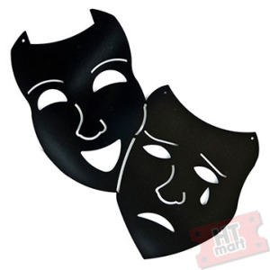
 | 1 | 2 | 3 | 4
Genre vs. Original  ‘Time Period/Setting’ | Student shows no commitment to genre and the original script. Little understanding of the original scene is evident. | Student shows some connection between the new genre and the original script. Comic shows little understanding of the original scene. | Student shows good connections between the new genre and the original script. Understanding of the original scene is evident. | Student shows excellent connections between the new genre and the original script. Shows clear and obvious understanding of the original scene.
Contextual Influences:  ‘Language’ | Student does not acknowledge genre’s effect on language | Student shows a language choice; however, there is disconnect from the genre | Student shows clear awareness of language and connection to the text | Student shows excellent understanding of setting and time period and how it relates to the text.
Contextual Influences:  ‘Characters, Costumes, Staging’ | Student shows no commitment to their genre choice with no evidence of connecting their theme to characters, costumes or staging. | Student gives some commitment to their genre choice and shows some connections to characters, costumes and staging. | Student shows good commitment to genre choice; connections between genre and characters, costumes and staging are evident. | Student shows excellent commitment to genre choice: clear and thought out connections are made between the genre and characters, costumes and staging.
Representation of Information:  ‘Comic, Presentation’ | Comic is incomplete and shows no connection between the genre choice and creative choices (colour, layout, text etc). Comic is messily drawn. | Comic shows fair presentation. Student shows some understanding of genre in creative choices (colour, layout, text etc). Comic is a little messy (pencil lines showing etc). | Comic is well presented and laid out in an aesthetic manner; genre choice is evident in creative choices (colour, layout text).  Comic is cleanly presented (no pencil lines etc). | Comic is very well presented and laid out in an aesthetic manner with clear connections between creative choices (colour, layout, text) and the genre chosen. Comic is cleanly presented (no pencil lines etc).
Artist’s Statement  (100 words) | Student does not explain genre choice or how it affects the scene. | Student explains genre choice but shows little understanding of how the scene is affected. | Student shows good understanding of the genre chosen and gives a good explanation of how the scene is benefited. | Student shows excellent understanding of their genre and gives an excellent explanation of how this scene has been affected.
/20

