Final Project: Creative Writing
Due Monday (Feb 16)
Part 1
Put together an anthology of the Writing you have done in this unit. This booklet must include:
- Title Page (Tidy with an image reflecting the unit: drawn or computer)
- Table of Contents
- Beginning Paragraph* (extended and turned into a story)
- Vivid Memory or Fear Story*
- Sundae Descriptive Paragraph*
- The Most Interesting Man in the World Commercial

Part 2
Choose one of the highlighted assignments and do a good copy of your story. This good copy must be:
- Edited twice: once by yourself and once by a friend
- Follow the guidelines of ‘Stylistic Techniques for Writing’
- Typed
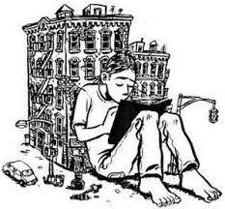
Marking (see rubric on back)
Completed Booklet /5
Secondary Assignments /5ea=15
Primary Assignment /20
___________________________________________
Total /40

