Ancient Chinese Beliefs

CONFUCIANISM
Always do your duty and what is right.

1. What was the real name of Confucius?

_________________________________________________________________________________________

a. Who was he?

_________________________________________________________________________________________

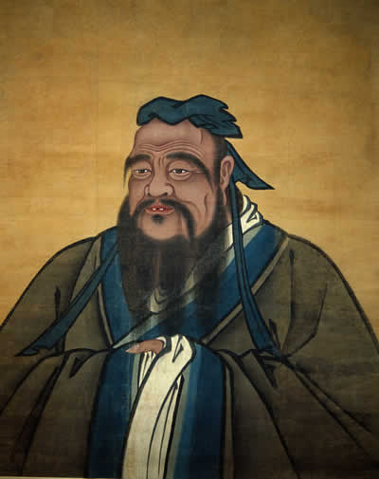

2. What kinds of writings form the basis of the Confucian philosophy?

a. Where are these writings collected and contained?

________________________________________________________
________________________________________________________
3. Define the following principals:
a) Li
b) Ren
c) Shu
d) Yi
e) Xiao

4. What are the 5 principal relationships od Confucianism?
___________________________________________________________________________________________________________________________________________________________________________________________________________________________________________________________________________

Confucius is credited with a number of very wise sayings:

- Forget injuries; never forget kindness.

- I hear and I forget. I see and I believe. I do and I understand.

- In a country well-governed, poverty is something to be ashamed of. In a country badly-governed, wealth is something to be ashamed of.

- To see what is right, and not do it, is want of courage, or of principle.

- To be a good learner you must be teachable. Respect is the cornerstone of all education.

- Have no friends not equal to yourself.

- Action takes precedence over words.
- To learn without thinking is labour in vain. To think without learning is desolation.
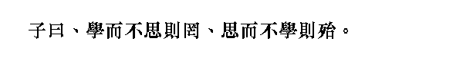
- Do not be concerned about others not appreciating you. Be concerned about your not appreciating others.
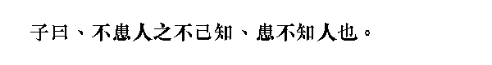
3. What kinds of values and rules does Confucius think people should live by?

_________________________________________________________________________________________

_________________________________________________________________________________________

LEGALISM
5. Who is Han Fei?
_________________________________________________________________________________________

_________________________________________________________________________________________

6. What are the 5 legalist principals?

_________________________________________________________________________________________

_________________________________________________________________________________________

_________________________________________________________________________________________

_________________________________________________________________________________________

_________________________________________________________________________________________

_________________________________________________________________________________________

DAOISM
Be ‘at one’ with the natural world and do not strive for things.

7. What are the major Daoist Principals?

_________________________________________________________________________________________

_________________________________________________________________________________________

_________________________________________________________________________________________

_________________________________________________________________________________________

_________________________________________________________________________________________

_________________________________________________________________________________________

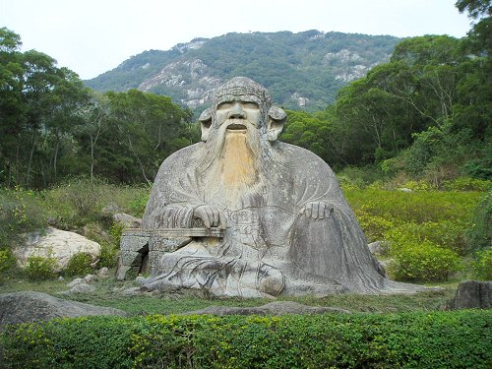
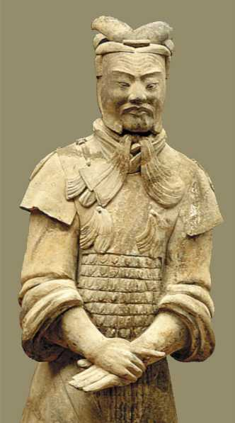

Lao Zi, was actually only called that as a nickname. It means ‘the Old Boy’, and comes from a story about how his mother was made pregnant by a falling star, and that she was pregnant so long that when he was finally born he was born an old man! There are also many funny stories about him being friends with Confucius, but no-one knows if they even lived at the same time.

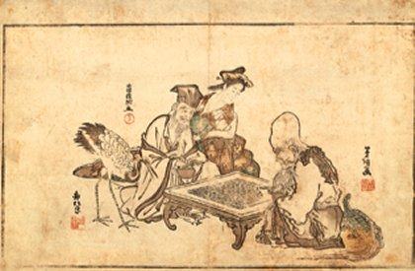

8. How did Daoism teach its followers to achieve lasting peace?

______________________________________________________________________________________

______________________________________________________________________________________

a. What kinds of things were unnecessary or undesirable under Daoism?

- ______________________________________________________________________________________

- ______________________________________________________________________________________

- ______________________________________________________________________________________

Most of the Dao rules are actually guidelines for the emperor to follow if he wanted to rule correctly. The funny thing is, most of them are the opposite of what you would expect:

Some examples are:

- The most effective course of action is always to do nothing.
- Slaughter the talented, and everybody will benefit.
- Good fortune and disaster are identical.
- Encourage ignorance so the shrewd [clever] will be impotent [powerless].

One good one is: ‘Govern quietly, and the people will realise that they are responsible for their own well-being.’

And another: “The journey of a thousand miles begins with your feet!’

7. What is the most important visual symbol of Daoism?

_________________________________________________________________________________________

a. Draw it:

b. What does this symbol mean?

______________________________________________________________________________________

______________________________________________________________________________________

______________________________________________________________________________________

c. What do each of the sides symbolise?

- ______________________________________________________________________________________

- ______________________________________________________________________________________

COMPARISON OF THE 3 PHILOSOPHIES

PHILOSOPHY | HOW YOU ARE SUPPOSED TO BEHAVE | GOOD THINGS ABOUT THE PHILOSOPHY | BAD THINGS ABOUT THE PHILOSOPHY
CONFUCIANISM
DAOISM
Legalism
Buddhism

